**Lab 3: Frequency Response of Transistor Amplifier**

**Keegan** **Smith**

**Bench** 02

**Electronics** II Lab

**EECE.3120 803**

**Date submitte**d 09/20/2022

**Due date** 09/21/2022

1. **SUMMARY**

**N/A**

1. **EQUIPMENT**

**Table 1. Equipment**

|  |  |  |
| --- | --- | --- |
| **Equipment Type** | **Details** | |
| * Oscilloscope | *Make:* | Tektronix |
| *Model:* | MDO3014 |
| *Serial Number:* | CO44915 |
| * Digital Multimeter | *Make:* | Keithley |
| *Model:* | 2110 5½ |
| *Serial Number:* | 8007691 |
| * DC Power Supply | *Make:* | Keithley |
| *Model:* | 2231A-30-3 |
| *Serial Number:* | Unable to acquire |
| * Function Generator | *Make:* | Tektronix |
| *Model:* | AFG1022 |
| *Serial Number:* | 1731386 |
| * Analog Discovery | *Make:* | Digilent |
| *Model:* | Analog Discovery 2 |
| *Serial Number:* | 210231B0DF82 |
| * Handheld Digital Multimeter | *Make:* | Tenma |
| *Model:* | 72-9385 |
| *Serial Number:* | H200487467 |
| * Breadboard * Bench “Shoebox” with connector cables, adapters, clips etc. | N/A | |

**Table 2. Components**

|  |  |  |
| --- | --- | --- |
| **Component Type** | **Quantity** | **Details** |
| Resistor |  | Decade Box |
| Resistor |  | 100 Ω |
| Resistor |  | 1k |
| Resistor |  | 2.2k |
| Resistor |  | 3.3k |
| Resistor |  | 4.7k |
| Resistor |  | 10k |
| Resistor |  | 100k |
| Resistor |  | 470k |
| 25V electrolytic |  | 1 μF |
| 25V electrolytic |  | 10 μF |
| 25V electrolytic |  | 100 μF |
| Transistor |  | 2N3904 |
| Transistor |  | 2N3906 |
| Power Brick |  | +/- 12 volts |

1. **INTRODUCTION**

**N/A**

1. **CIRCUIT DESCRIPTION**

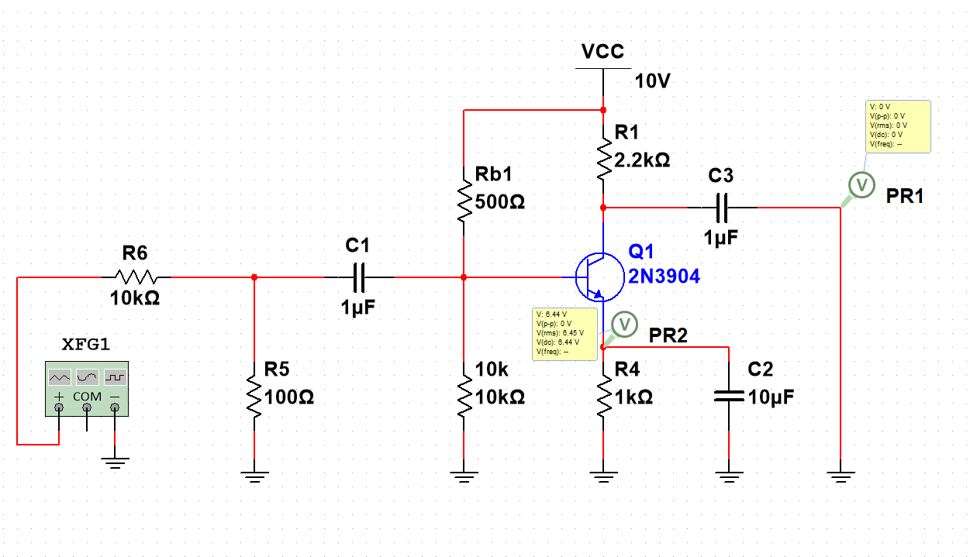Figure 1. Common-Emitter Amplifier

Figure 2. Common-Base Amplifier

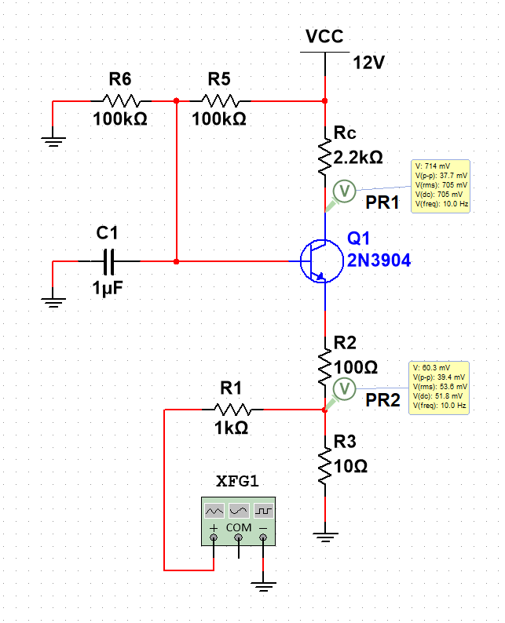

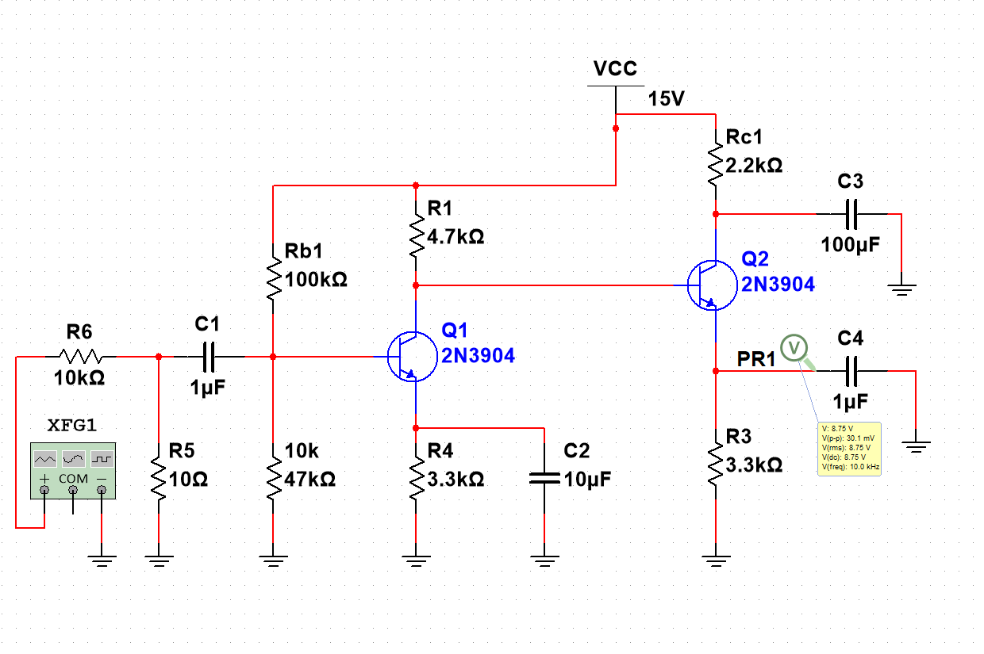Figure 3. Multi-stage

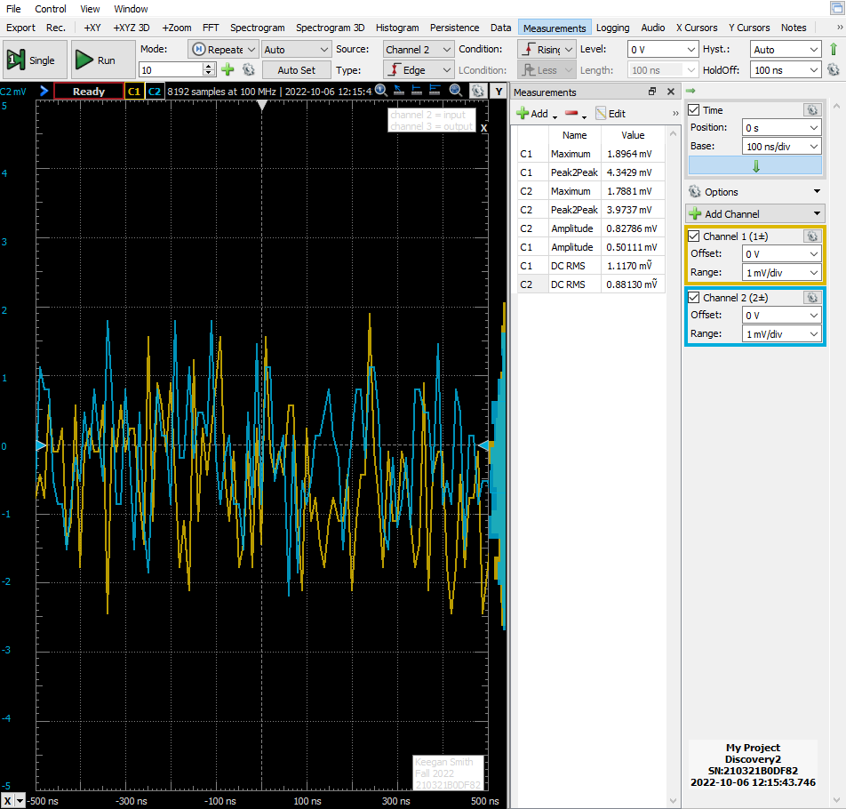Figure 5. Common-Emitter Amplifier, Low Frequency Response

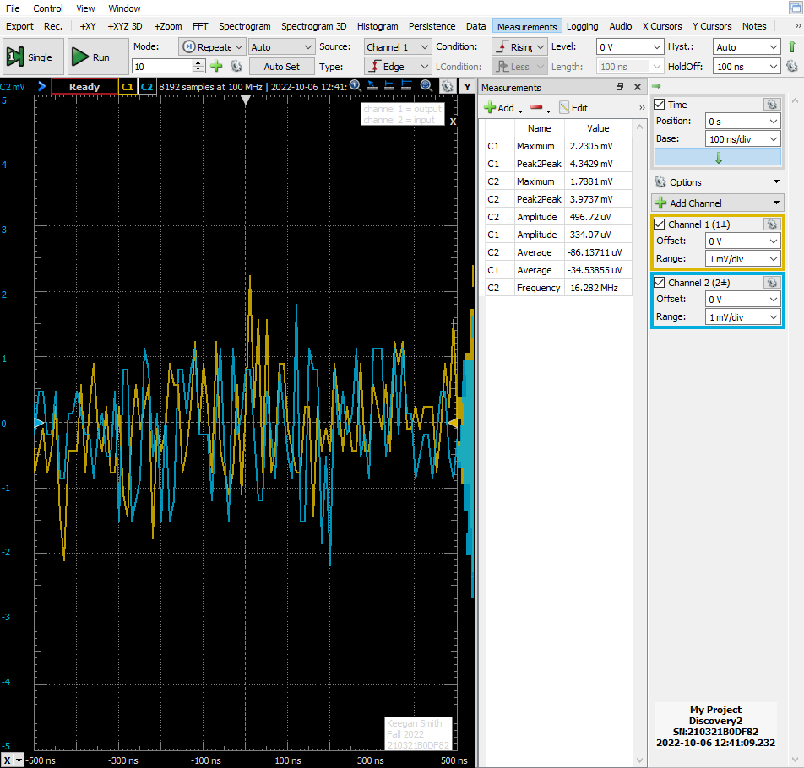Figure 6. Common-Emitter Amplifier Low Frequency response (1.59Hz)

Figure 7. Common-Emitter Amplifier Low Frequency Response (0.159Hz)

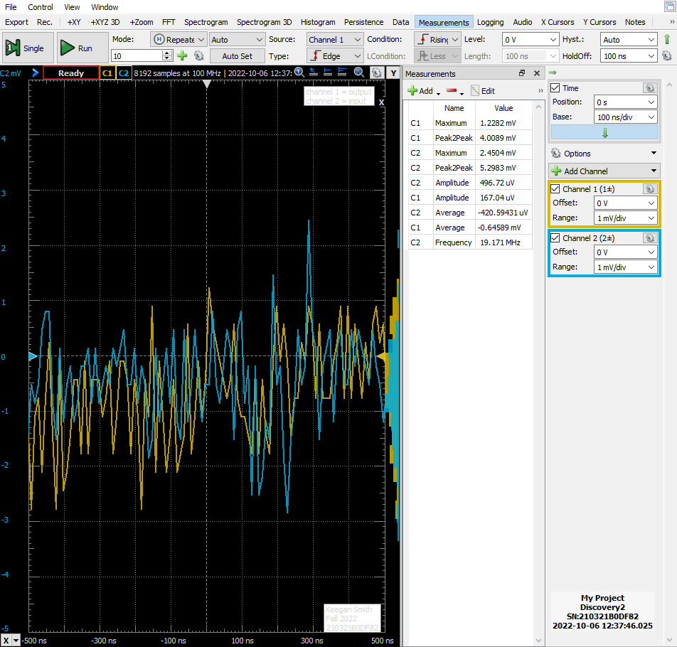

Figure 8. Common-Emitter Amplifier Bode Plot

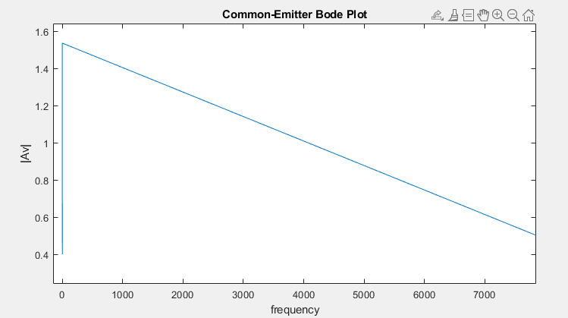

Figure 9. Common-Base Amplifier

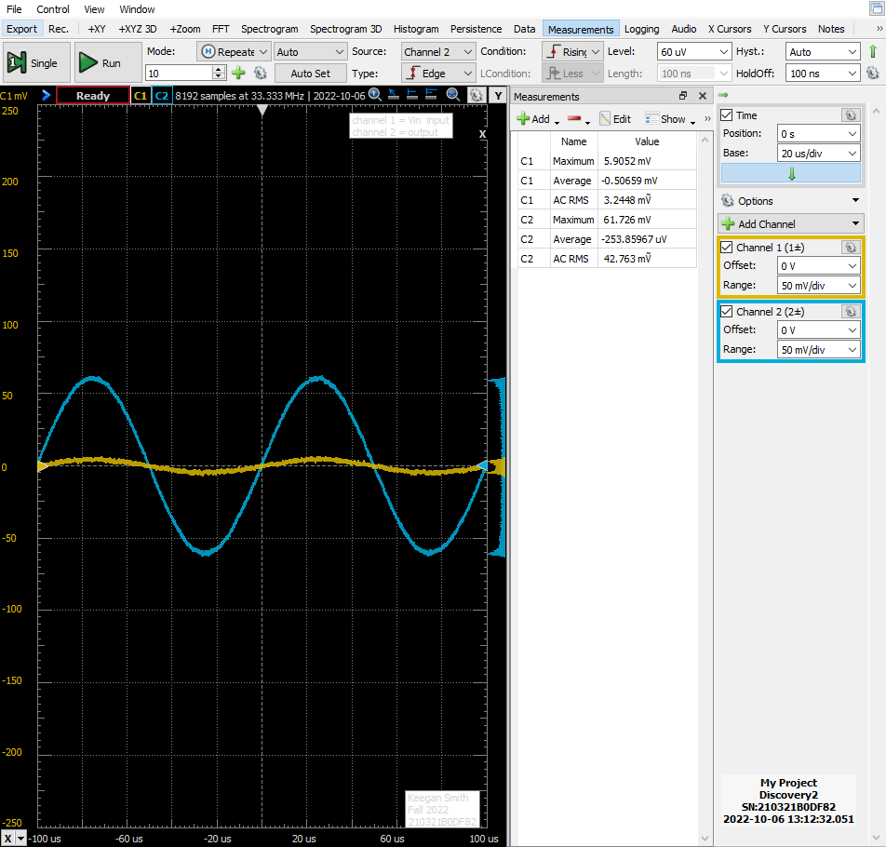

Figure 10. Multi-Stage Amplifier Part B

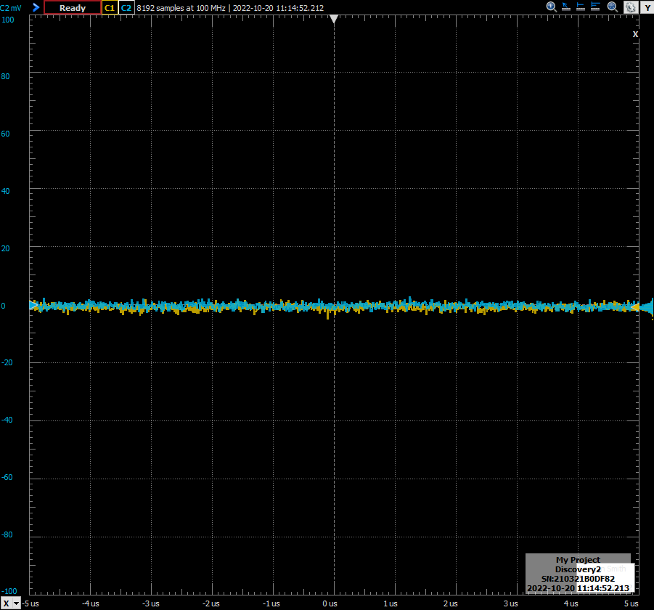

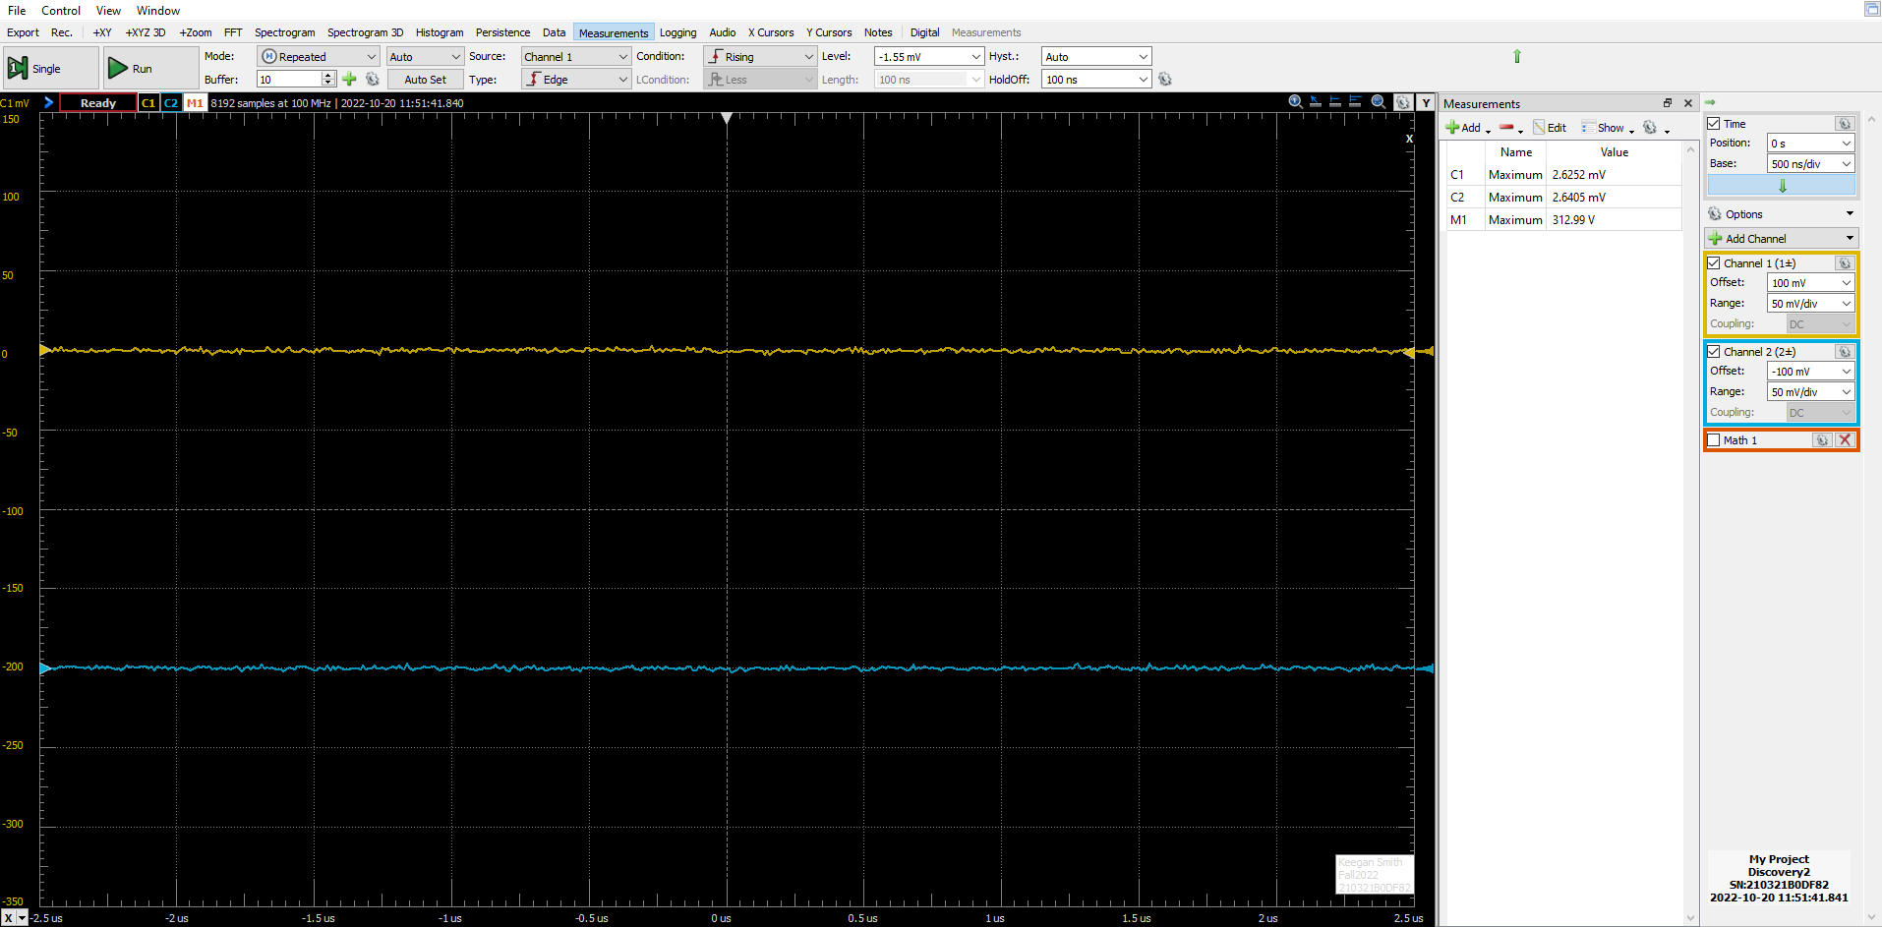Figure 11. Multi-Stage Amplifier Part D (fL/10)

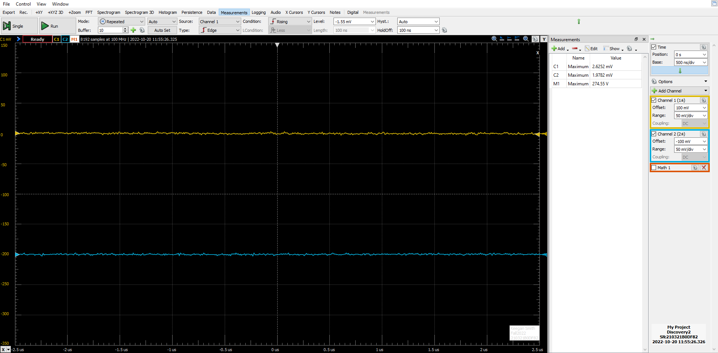Figure 12. Multi-Stage Amplifier Part D (fL/100)

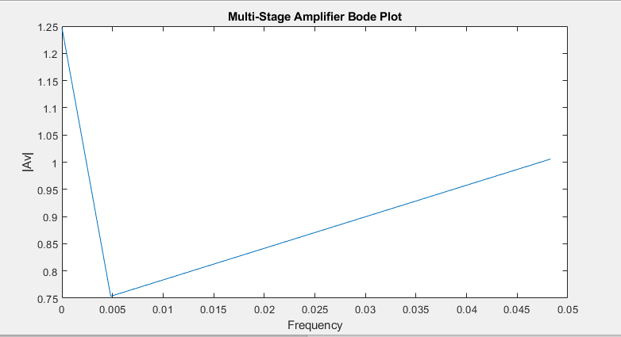Figure 13. Multi-Stage Amplifier Bode Plot

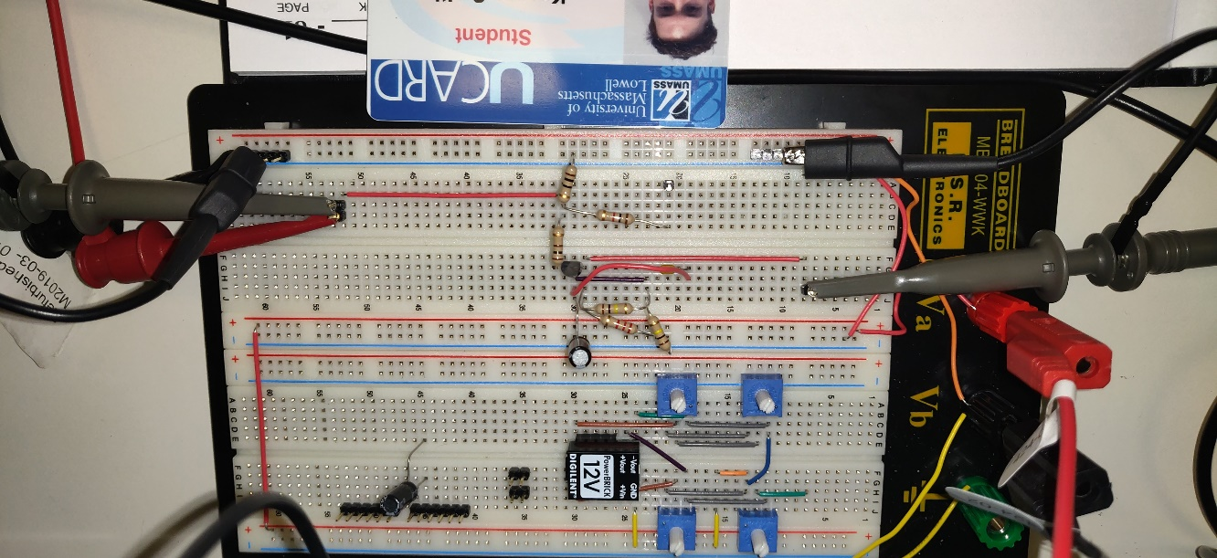Figure 14. Common-Base Amplifier Physical Circuit

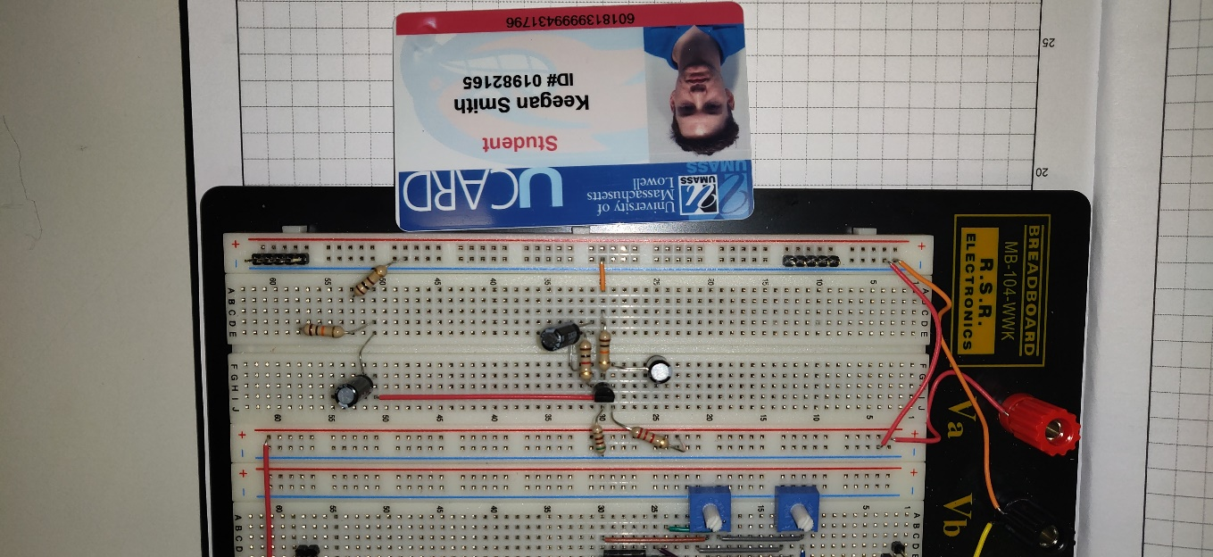Figure 15. Multi-Stage Amplifier Physical Circuit

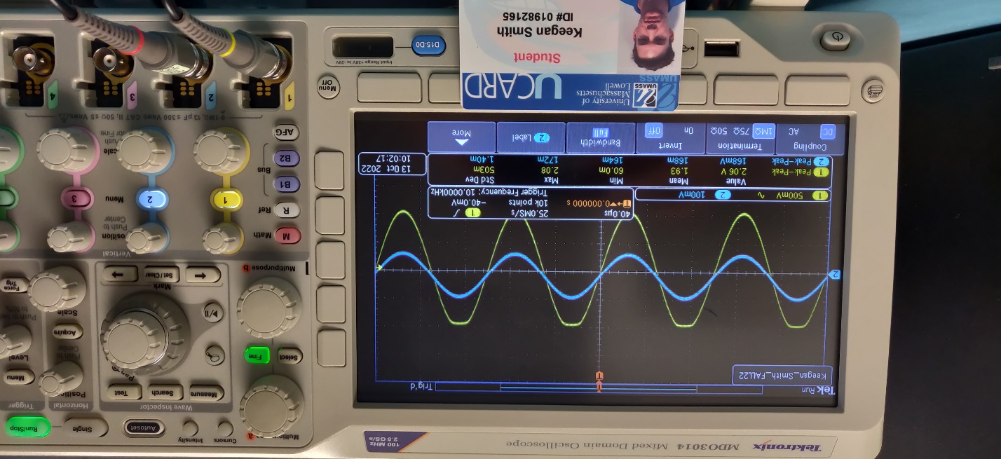Figure 16. Common-Base Amplifier Output with Oscilloscope

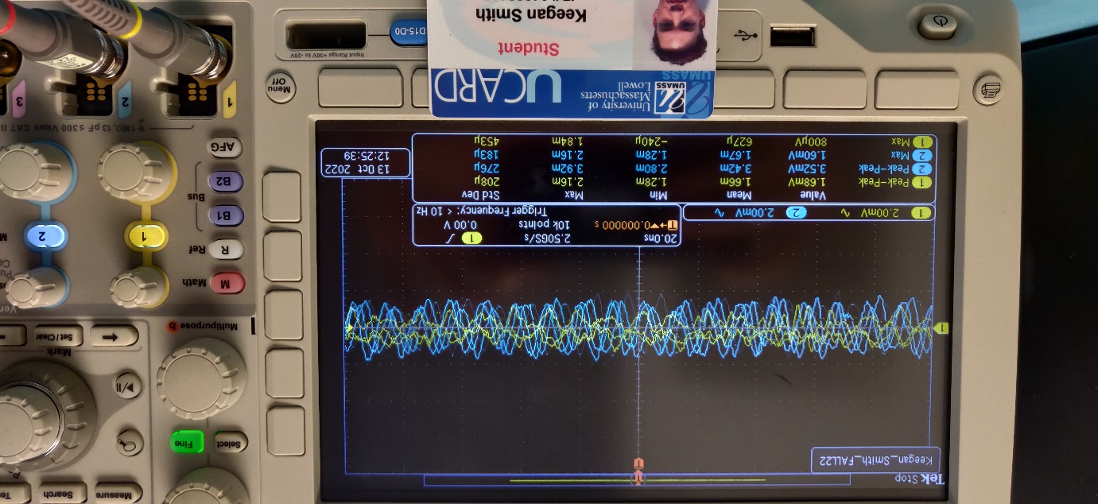Figure 17. Multi-Stage Amplifier Output with Oscilloscope

1. **MEASUREMENTS**

Table 1. Common-Emitter Amplifier

|  |  |  |
| --- | --- | --- |
| **DC Voltages** | **Measured Data** | **Calculated Values** |
| VC | 5.98 V |  |
| VB | 6.72 V |  |
| VE | 5.93 V |  |
| IC |  | 5.98mA |
| gm |  | 0.2392 A/V |

Table 2. Common-emitter Amplifier Low Frequency Response

|  |  |
| --- | --- |
| **Component** | **Measured Value** |
| Vout | 334.07 µV |
| Vin | 496.72 µV |
| Avo (Vout/Vin) | 0.67255 V |
| gm | 99.502mA/V |
| *f*L | 15.915Hz |
| *f*L/10 | 1.5915Hz |
| Aov (at *f*L/10) | 0.39973 V/V |
| *f*L/100 | 159.15mHz |
| Aov (at *f*L/100) | -1.5356 V/V |

Table 3. Common-Emitter Amplifier High Frequency Response

|  |  |
| --- | --- |
| **Component** | **Measured Value** |
| *f*C | 786.16Hz |
| 10(*f*C) | 7.8616KHz |
| Vout | 4.00 mV |
| Vin | 8.00 mV |
| Av | 0.5 V/V |

Table 4. Common-Base Amplifier

|  |  |
| --- | --- |
| **Component** | **Measured Value** |
| Vout | 61.726 mV |
| Vin | 5.9052 mV |
| AV (Vout/Vin) | 10.4528 V/V |

Table 5. Common-Base Low Frequency Response

|  |  |
| --- | --- |
| **Component** | **Measured Value** |
| *fC*  (Stock C) | 1.59 Hz |
| *fC*  (Increased C) | 200 mHz |

Table 6. Common-Base High Frequency Response, RC = 10KΩ

|  |  |
| --- | --- |
| **Component** | **Measured Value** |
| Am  (Increased RC) | 25.4545 V/V |
| Am  (With 0.1µF BE capacitor) | 51.8181 V/V |

Table 7. Multi-Stage Amplifier

|  |  |
| --- | --- |
| **Component** | **Measured Value** |
| Vin | 2.2305 mV |
| Vout | 2.7816 mV |
| Am | -1.2471 V/V |
| *f*L  (calculated) | 482.28 mHz |
| *f*L/10 | 0.0482 Hz |
| Am  *(f*L/10) | 1.0058 V/V |
| *f*L/100 | 0.00482 Hz |
| Am  *(f*L/100) | 0.7535 V/V |

1. **DISCUSSION**

In section one of this laboratory experiment, the BJT common-emitter amplifier was constructed. This circuit configuration is called so because the emitter of the transistor is grounded, collector is connected to power, and the base is amplifier input. During the beginning of this section, R­B1 need to be found to finish the voltage divider on the base of the transistor, so that VB = ~6-7v. I found this value to be 500 Ω via simulations and the physical circuit confirmed this value, with a VB = 6.78v. The rest of the results make sense from this value and can be found in table 1.

The next part of section one was the low frequency response of the common-emitter amplifier. In this section Vout and Vin and then the gain of the amplifier is calculated. I believe that I used the wrong equation during the measuring of the low-frequency cutoff. To calculate this, I used equation 1 instead of equation 2.

equation 1.

, *f*  being the original frequency of the load equation 2.

equation 3.

Therefore, my results for gain during the frequency response measurements will not be correct for the whole of this experiment. Hence also why the bode plots do not look correct. However, measurement for Vin and Vout were taken at the correct locations on the circuit and the gain equation (equation 3) was used for its own calculation. The values for Vin and Vout are “maximum” values taken from oscilloscope readings, and this is noted in my notebook to avoid confusion in future reference.

Section two of the procedure includes constructing a common-base amplifier. Called so due to the base of the transistor being grounded, the emitter the input, and the collector being the output. I found the outputs from this section to be the easiest to read and visualize. For example, see figure 16, common-base amplifier output with oscilloscope. Here, channel 1 is the input wave, and channel 2 is the output of the amplifier. The gain I saw from this was the highest in the entire experiment, but there are a few factors for this, including, construction, input voltage dividers, and the input signals. This section had the highest input signal voltage, 1 V.

The Third and final section of this lab was to construct a multi-stage amplifier using a PNP and a NPN transistors. The first stage of this amplifier is the Common-Emitter amplifier. This part had the input wave on the base of the NPN transistor. The output from stage 1 (The Collector from the NPN transistor) connects to the base of the PNP transistor. This stage uses a common-collector amplifier with the output on the emitter. This part of the lab was difficult due to the voltage divider reducing the input voltage from Vgen by a factor of 1000. Also due to this, and my miscalculation for the *fL* frequencies, I was unable to acquire a proper bode plot.

1. **CONCLUSION**

In conclusion, transistors and amplifiers are an extremely important circuit component circuit systems to have understandings and experience with. This experiment increased my understanding of how amplifiers work on their own and together in multi-stage systems as well as load frequencies and gain. Yet again, due my mistake with the calculations of *fL­* I am reminded to ask for help from the TA or another student when confused or not fully understanding a section of the lab.

1. **QUESTIONS**

**N/A**

1. **REFERENCES**
2. York, B. (n.d.). Audio Amplifier Circuit. Retrieved from <http://www.ece.ucsb.edu/Faculty/rodwell/Classes/ece2c/labs/Lab3_2C_2007.pdf>
3. Recitation Textbook
4. “Lab 3: Frequency Response of Transistor Amplifier.” *Lab3 Lab Procedure*, University of Massachusetts Lowell, 2017.